UNITED STATES
SECURITIES AND EXCHANGE COMMISSION
Washington, D.C. 20549

SCHEDULE 14A

Proxy Statement Pursuant to Section 14(a) of the
Securities Exchange Act of 1934 (Amendment No. )

☑ |  |  |  |  |  | Filed by the Registrant |  |  |  |  |  | ☐ |  |  |  |  |  | Filed by a Party other than the Registrant
CHECK THE APPROPRIATE BOX:
☐ |  |  |  |  |  | Preliminary Proxy Statement
☐ |  |  |  |  |  | Confidential, For Use of the Commission Only (as permitted by Rule 14a-6(e)(2))
☐ |  |  |  |  |  | Definitive Proxy Statement
☑ |  |  |  |  |  | Definitive Additional Materials
☐ |  |  |  |  |  | Soliciting Material Under Rule 14a-12



Paylocity Holding Corporation

(Name of Registrant as Specified In Its Charter)
(Name of Person(s) Filing Proxy Statement, if Other Than the Registrant)

PAYMENT OF FILING FEE (CHECK THE APPROPRIATE BOX):
☑ |  |  |  |  |  | No fee required.
☐ |  |  |  |  |  | Fee paid previously with preliminary materials
☐ |  |  |  |  |  | Fee computed on table in exhibit required by Item 25(b) per Exchange Act Rules 14a-6(i)(1) and 0-11

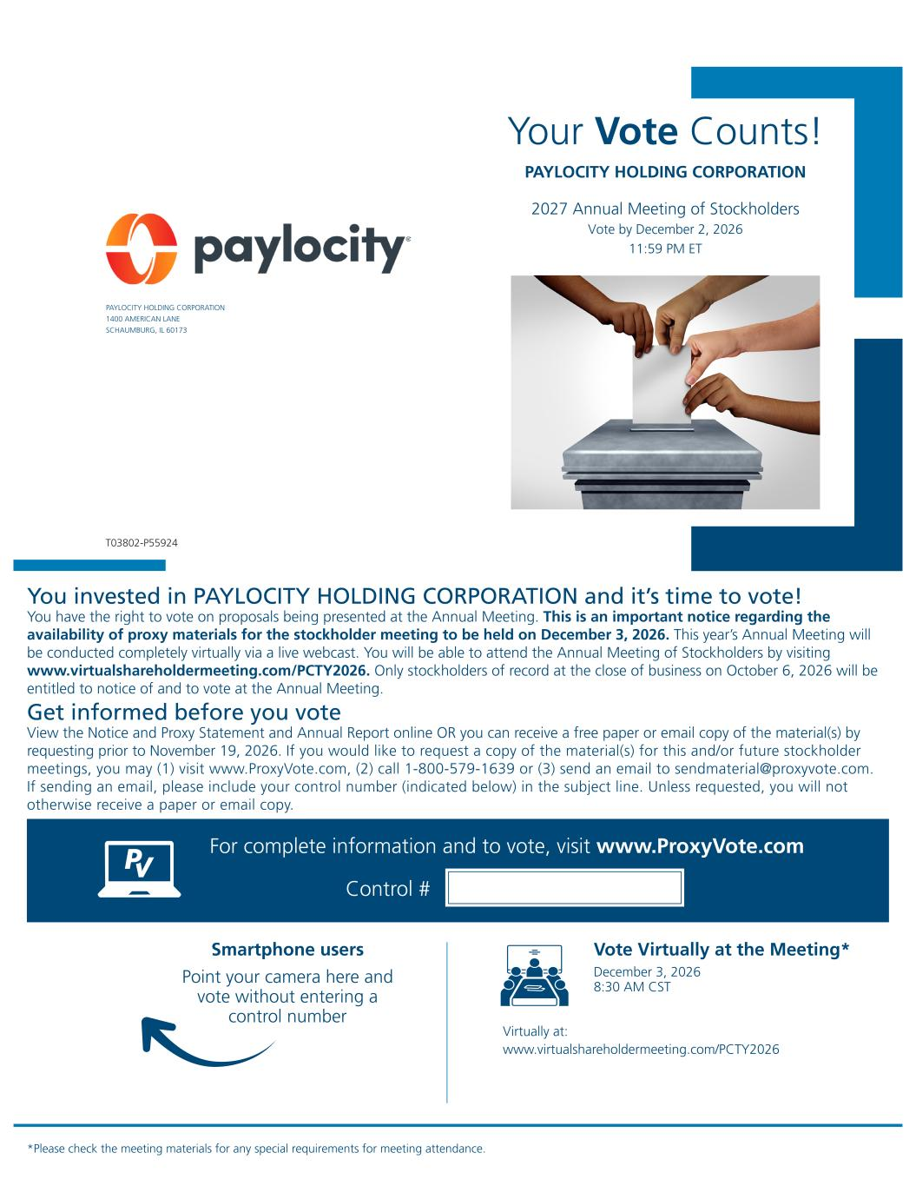
Your Vote Counts! Smartphone users Point your camera here and vote without entering a control number For complete information and to vote, visit www.ProxyVote.com Control # T03802-P55924 *Please check the meeting materials for any special requirements for meeting attendance. PAYLOCITY HOLDING CORPORATION PAYLOCITY HOLDING CORPORATION 1400 AMERICAN LANE SCHAUMBURG, IL 60173 2027 Annual Meeting of Stockholders Vote by December 2, 2026 11:59 PM ET You invested in PAYLOCITY HOLDING CORPORATION and it’s time to vote! You have the right to vote on proposals being presented at the Annual Meeting. This is an important notice regarding the availability of proxy materials for the stockholder meeting to be held on December 3, 2026. This year’s Annual Meeting will be conducted completely virtually via a live webcast. You will be able to attend the Annual Meeting of Stockholders by visiting www.virtualshareholdermeeting.com/PCTY2026. Only stockholders of record at the close of business on October 6, 2026 will be entitled to notice of and to vote at the Annual Meeting. Get informed before you vote View the Notice and Proxy Statement and Annual Report online OR you can receive a free paper or email copy of the material(s) by requesting prior to November 19, 2026. If you would like to request a copy of the material(s) for this and/or future stockholder meetings, you may (1) visit www.ProxyVote.com, (2) call 1-800-579-1639 or (3) send an email to sendmaterial@proxyvote.com. If sending an email, please include your control number (indicated below) in the subject line. Unless requested, you will not otherwise receive a paper or email copy. Vote Virtually at the Meeting* December 3, 2026 8:30 AM CST Virtually at: www.virtualshareholdermeeting.com/PCTY2026

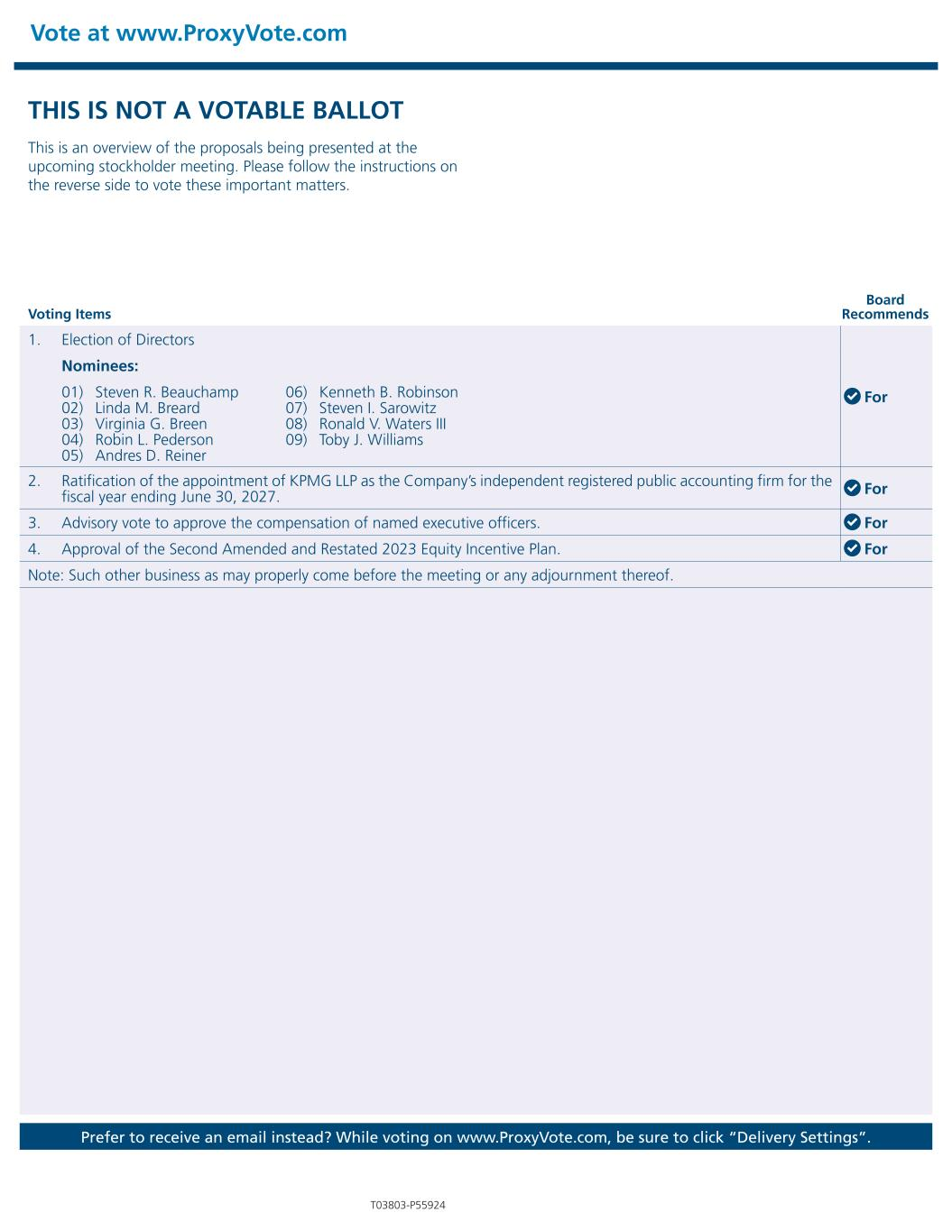
Vote at www.ProxyVote.com Voting Items Board Recommends T03803-P55924 Prefer to receive an email instead? While voting on www.ProxyVote.com, be sure to click “Delivery Settings”. THIS IS NOT A VOTABLE BALLOT This is an overview of the proposals being presented at the upcoming stockholder meeting. Please follow the instructions on the reverse side to vote these important matters. 1. Election of Directors For Nominees: 01) Steven R. Beauchamp 02) Linda M. Breard 03) Virginia G. Breen 04) Robin L. Pederson 05) Andres D. Reiner 06) Kenneth B. Robinson 07) Steven I. Sarowitz 08) Ronald V. Waters III 09) Toby J. Williams 2. Ratification of the appointment of KPMG LLP as the Company’s independent registered public accounting firm for the fiscal year ending June 30, 2027. For 3. Advisory vote to approve the compensation of named executive officers. For 4. Approval of the Second Amended and Restated 2023 Equity Incentive Plan. For Note: Such other business as may properly come before the meeting or any adjournment thereof.

